**Meeting Agenda**

Training Tracker (TT) : Effective Workout Progress Monitoring

through Visual Analytics

Empowering Motivation with a Visual Fitness Performance Tracker

date | 12 – 03 – 2024 (10 : 30)

_______________________________________________________________________________________________________________

**discussion topics**

_______________________________________________________________________________________________________________

* still waiting for ethics approval..

* 19th Mar 14:30 meeting / 16th April 10:00 meeting

**weekly updates**

_______________________________________________________________________________________________________________

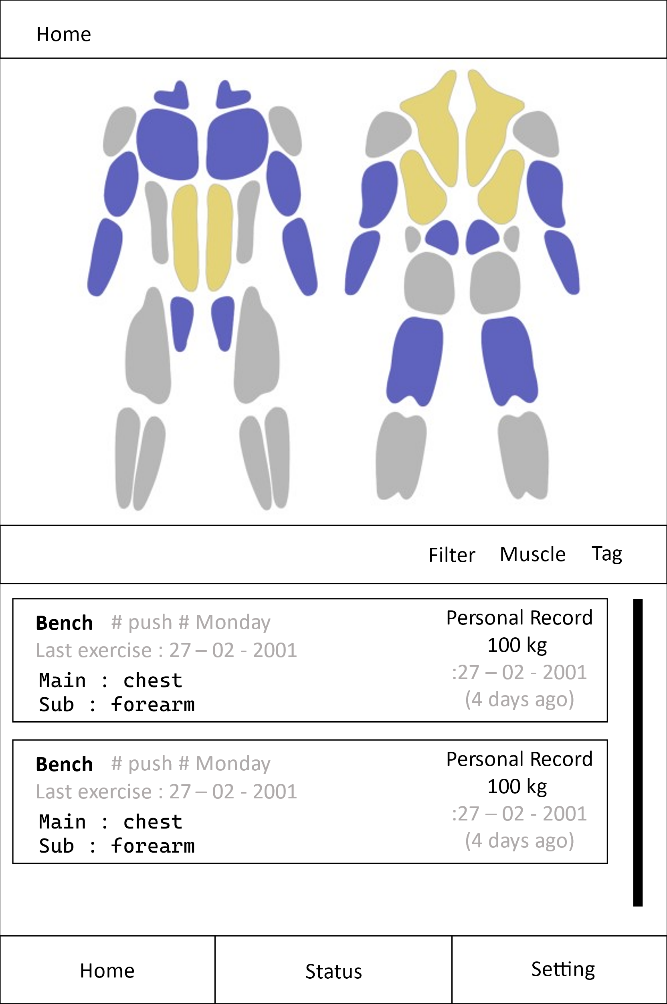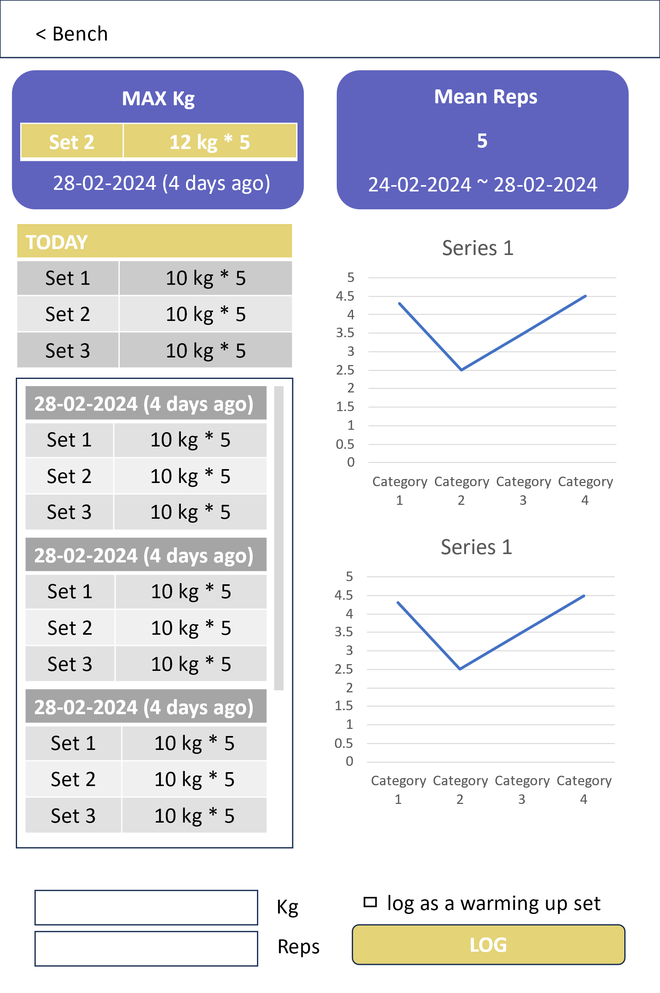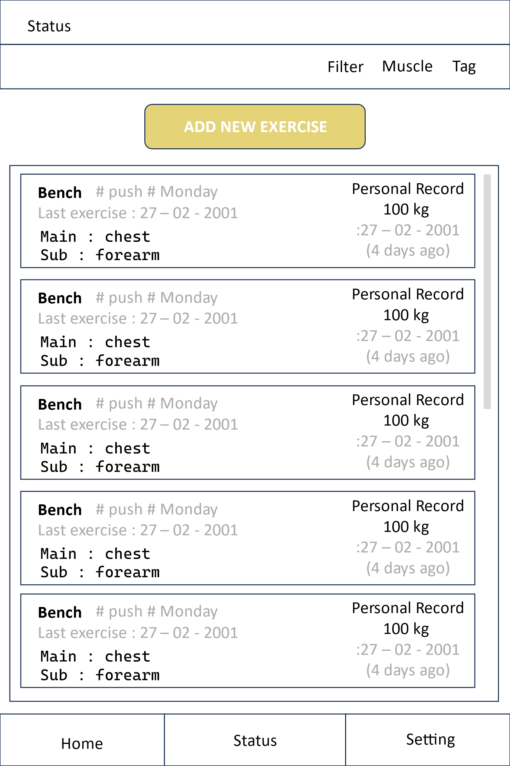 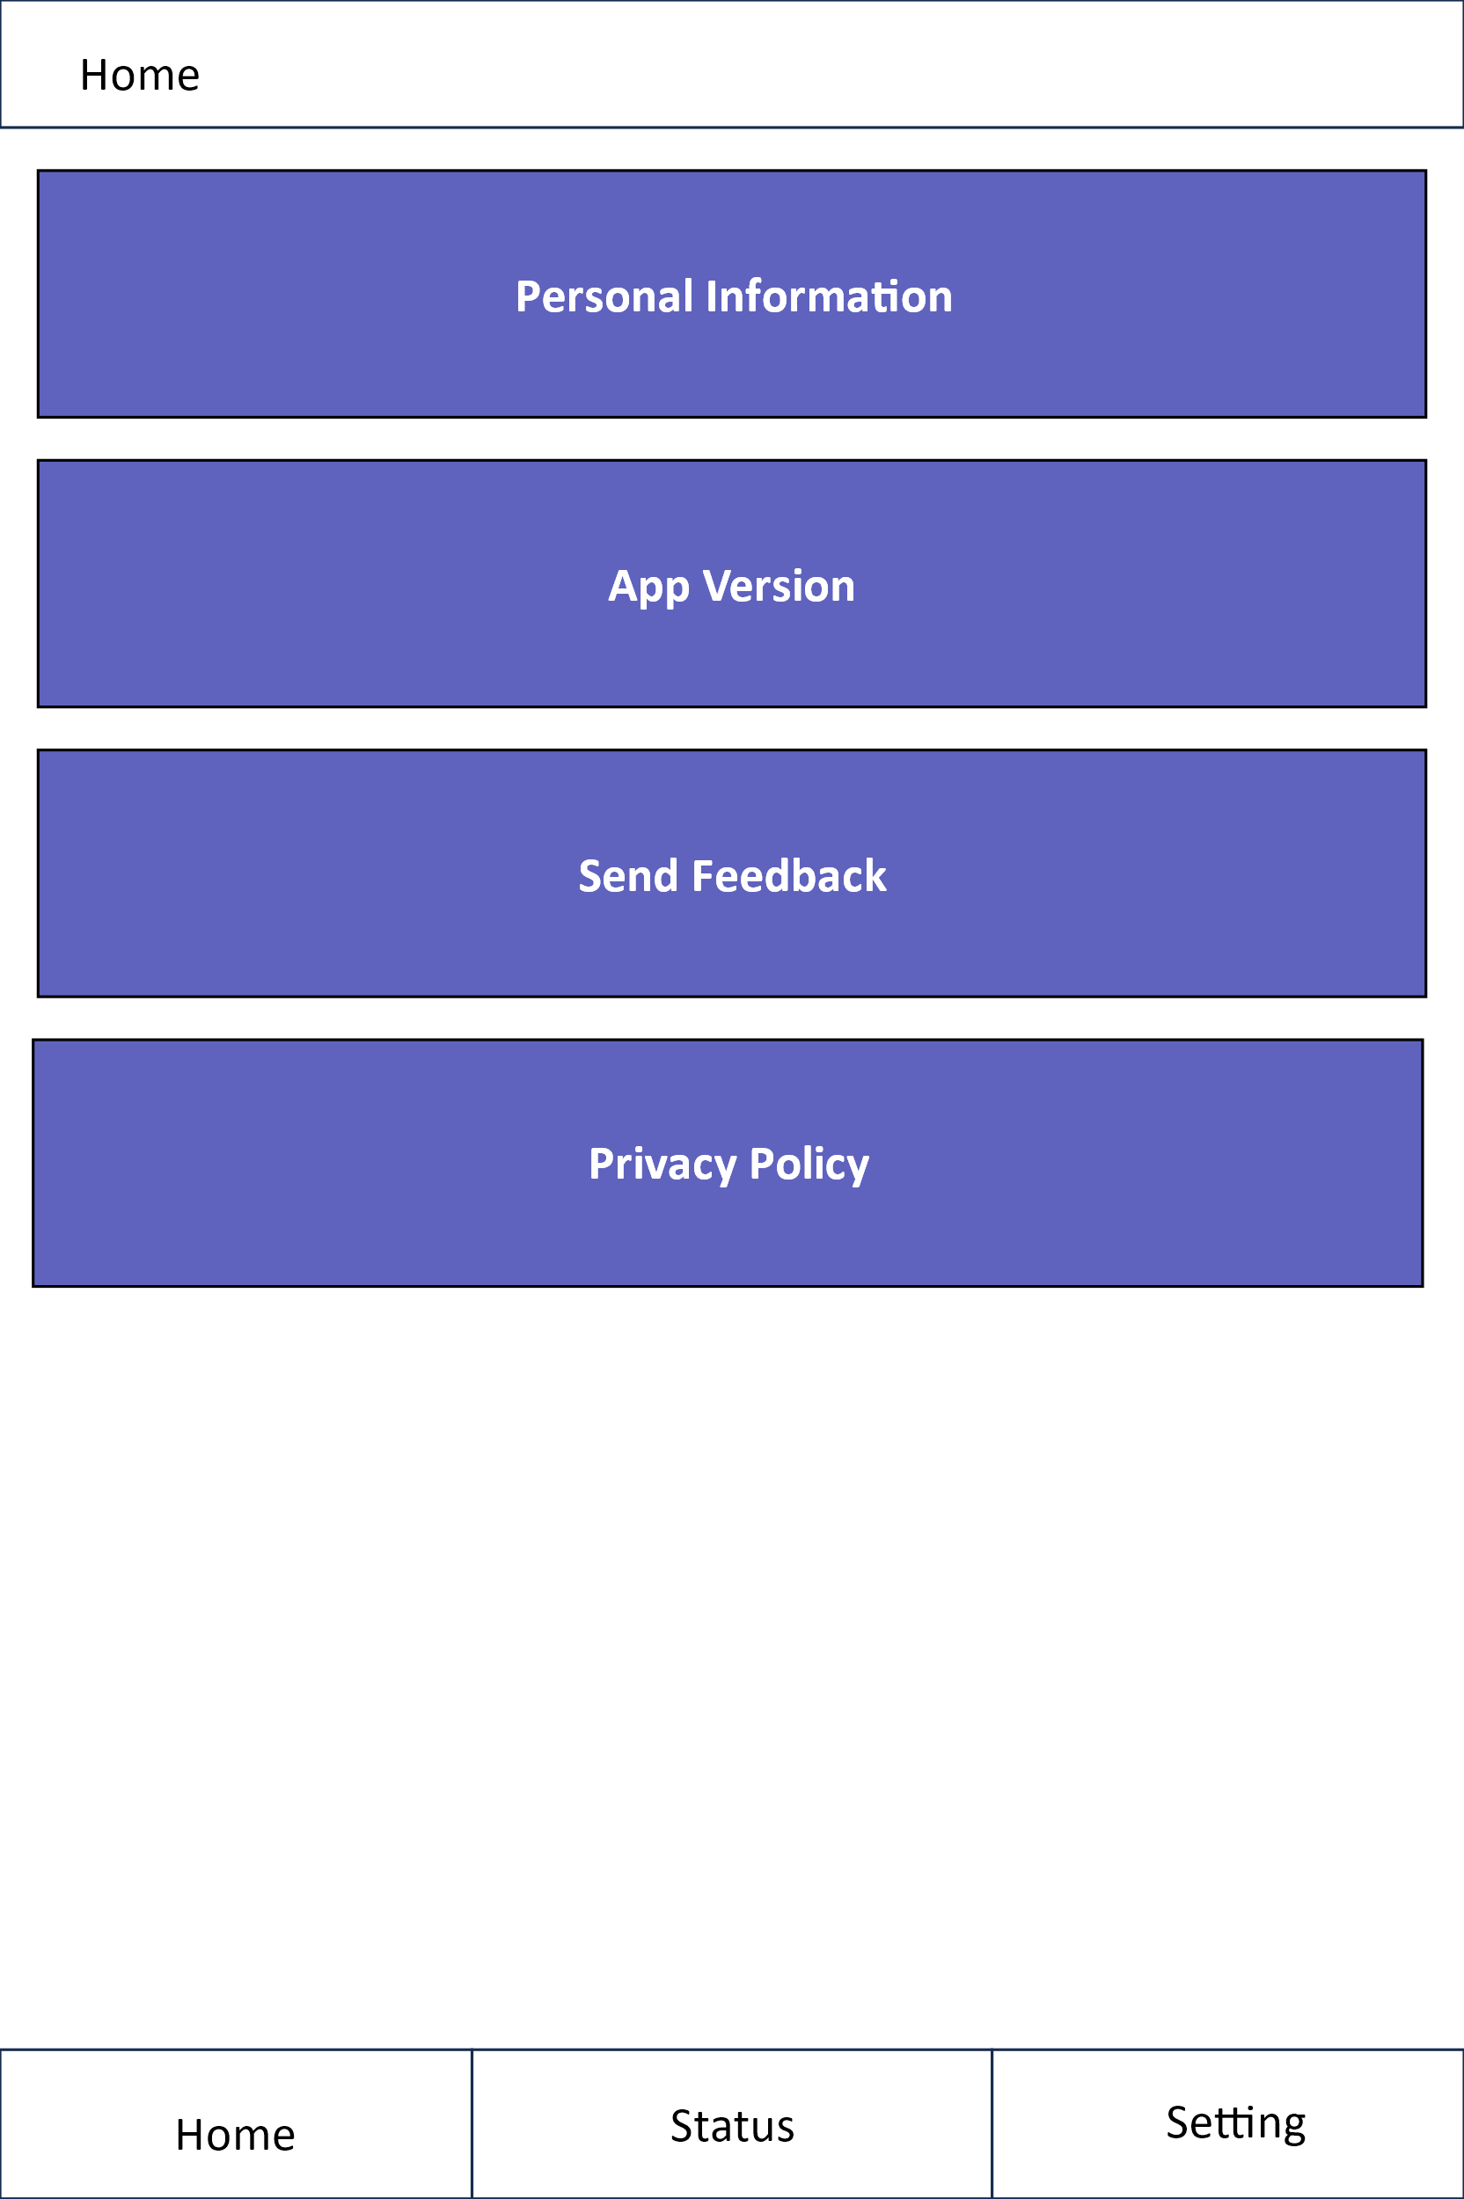

* made the developer account

* implementing the second version of the app

- click card to enter log

- improved card layout

- show the past records and the personal best record

- show analysis of the progress (graph – still need to connect it to user’s data, but frontend implementation is done)

- muscle visualisation (still need to work on colour change features, but I’ve done visualisation each muscle with vector graphics, used “inkscape”)

- designed app logo

- Find some errors and fixed (about data structures and classes)

- enhancing user experiences

(minimalise steps that user needs to take to log their progress, user can customise set recording, long click to delete a card with warning)

**priority tasks**

_______________________________________________________________________________________________________________

* finalising the second version of the app

* Upload app on google app store